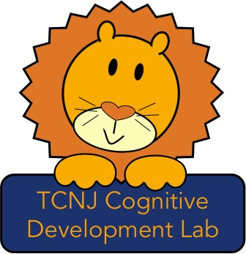

Thank you for your interest in working in the Cognitive Development Lab! To apply, please fill out the lab application and email it to
Dr. Stahl at stahla@tcnj.edu.

The requirements for the position include approximately 8 hours of lab time per week (typically between 9AM and 5PM), in addition to weekly lab meeting. Due to the amount of time it takes to get trained to work in the lab, preference is given to students who can commit to two consecutive semesters.

To work in the lab, you must be responsible, trustworthy, child-friendly, and intellectually curious. Experience working with children in some capacity is required; previous research experience is not required but you should take PSY121 before applying to the lab.

Every member of the Cognitive Development Lab will take part in all laboratory activities, from recruiting new child participants to taking part in intellectual discussions about the ongoing projects. If you are selected, here is a list of duties you can expect as part of your lab experience:

• Work one-on-one with Dr. Stahl to understand a project’s motivation, design, and results
• Watch footage of infant and child testing sessions to code and analyze the resulting data
• Assist with testing infant and child participants
• Call parents to invite them to have their child participate in the lab’s studies
• Schedule participants and answer parents’ questions about our research
• Recruit children from the community to participate in the lab’s studies
• Greet parents and their children when they arrive at the lab and escort them to/from the
parking lot
• Create experimental stimuli to be used in our studies
• Participate in weekly lab meetings to discuss the current literature on cognitive development or
new results from ongoing studies in the lab

Students who have worked in the lab for at least one semester may be eligible for PSY 492. This possibility and the associated requirements should be discussed with Dr. Stahl.

